Invitation to Training in Project Management

Making Projects Manageable

Dates: January 26 - 27, 2016

Training is starting at 9:00

Place: Uzhgorod, Etno – welness hotel „Ungvars’kyi“
http://www.ungvarskiy-hotel.com.ua/

Training Goal: to train participants in writing manageable and successful projects within Truly Together 2.0 program, in building partnerships, monitoring their implementation, reporting and promoting sustainable project results.

Trainers: Barbara Kollarova, Carpathian Foundation, Košice, Slovak Republic
Barbara works as a project manager at the Carpathian Foundation SK. She has got more than 15 years of experience in working for the NGO sector as well as in writing and implementing both national and international partner projects. She is also a lecturer and trainer in project management.

Martin Boršč, Enjoy the ride, civic association, Košice, Slovak Republic
Martin worked for the Slovak Youth Organisation IUVENTA for a few years and has got experience in writing, implementing and monitoring projects with involvement of young people on the local and regional level.

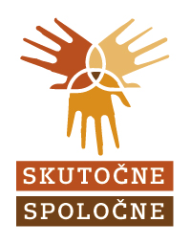
The project grant covers: accommodation of the participants, catering, travel costs, trainers, training handouts, interpretation and translation.

